**Univariate normal distribution**

$$K\left(X\right)=N\left(μ, σ^{2}\right)=\frac{1}{σ\sqrt{2π}}{e^{-\frac{1}{2}(\frac{x-μ}{σ})}}^{2}$$

$$K_{T}\left(T\right)=N(0.9, 0.09)$$

$$K_{S}\left(S\right)=N(0.8, 0.04)$$

In order to have max(KS) = max(KT), KS is multiplied by max(KT)/ max(KS).

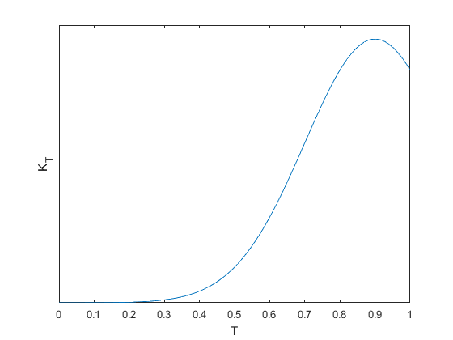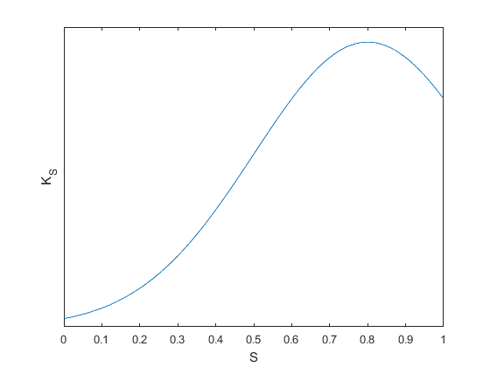

Fig. 1. KT(T) and KS(S).

**Bivariate normal distribution**

$$K\left(S,T\right)=N\left(μ, Σ\right), μ=\left[\begin{matrix}x_{1} \\ x_{2}\end{matrix}\right], Σ=\left[\begin{matrix}σ_{1}^{2} & 0 \\ 0 & σ_{2}^{2}\end{matrix}\right]$$

where, x1 = x2 = 1,

= 0.09 (same value used in KT), = 0.04 (same value used in KS)

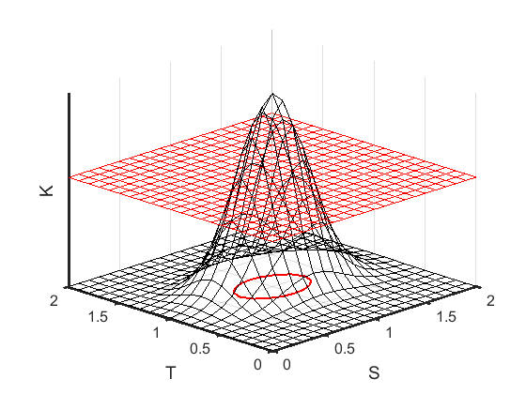

Fig. 2. K(S,T).

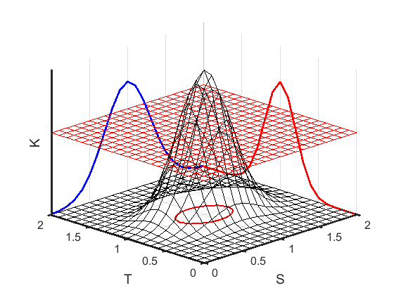

Fig. 3. K(S,T) with projections KS and KT.

Fig. 3. K(S,T) in region [0 1].